Assignment (3.4)

Implement a single classification model of your choice and try
to achieve at least an 80% F1 score on the wine dataset
provided by Sklearn.

Solution

- First we import all required libraries.
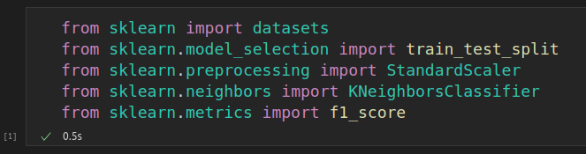
- Then load the wine dataset from sklearn.
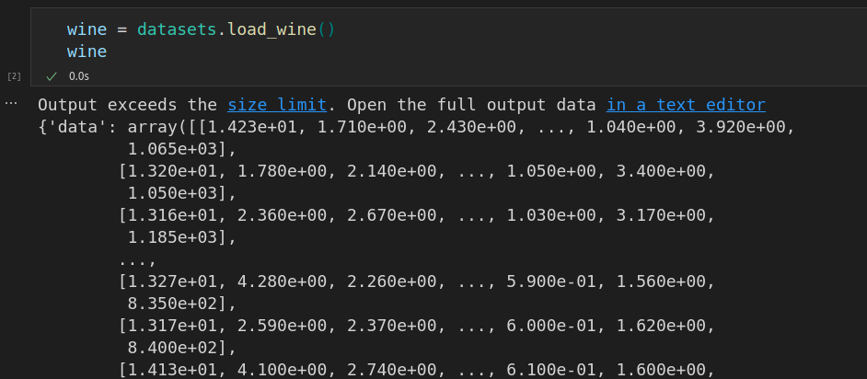
- Now, select last 4 columns of data as wine_x.
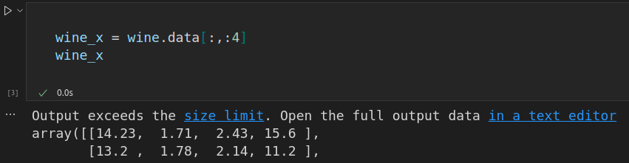
- And select target data as wine_y.
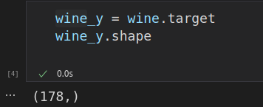

- Then split data into train and test, transform and fit transform.
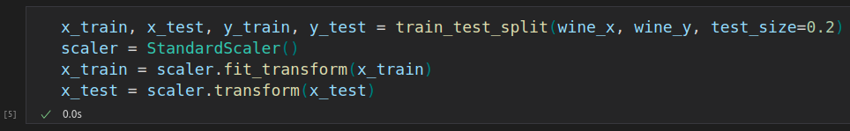
- Now use KneighborsClassifier as model.
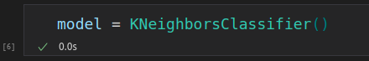

- Now, use model.fit.
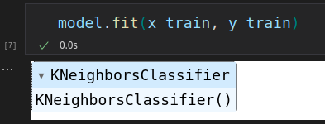

- Now, predict the model and show the f1 score.
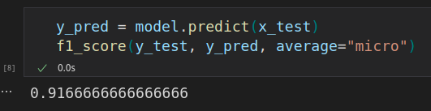

In the end, we are getting 91% accuracy.

